A Brief Look at Mathematical Advancements from the High Middle Ages to Late Middle Ages

Justin Butler

September 9th, 2020

**Introduction**

The Dark Ages was a time of little mathematical advancement up until the end of the eighth century. Burton (2011) stated that the Christian Church was the only place of intellectual life. The cause of the Dark Ages was due to many things leading up to and during. Two large contributors were the Black Death and the fall of the Roman Empire. The 9th century up to the 12th century denotes the start of massive intellectual resurgence. This period covers the Carolingian renaissance, Ottonian renaissance, and the 12th century renaissance.

Before the 14th century the philosophical views were very much Aristotelian. The influence of the Greeks prevented many to explore unknown concepts. Such concepts were not explored till the start of the Renaissance (14th century) when new philosophical views were becoming more common place. The church also influenced this as the church’s priorities were to teach leadership and skills that the church required. They did not need to explore new concepts and unknowns.

This paper will discuss some mathematicians and mathematical advancements from the High Middle Ages to the Late Middle Ages. Specifically, the 12th century up to the 14th century. The 12th century witnessed “the greatest mathematician of the middle ages” (Burton, 2011, p. 277) Named Fibonacci. His greatest contribution would be what is now referred to as the Fibonacci sequence. During the 13th century a mathematician named Jordanus Nemorarius solved the problem of the inclined plane; named by Archimedes. The 14th-century saw Nicole Oresme tackle the problem of infinite series with a geometric proof.

**Fibonacci**

Leonardo of Pisa, known as Fibonacci, was born in Pisa circa 1175 and studied in north Africa. Fibonacci traveled through the Mediterranean during which he observed the different numbering systems and realized that the Hindu-Arabic decimal system had enormous advantages over the Roman system used in his own country. Burton (2011) Stated that Fibonacci returned “to Pisa in 1202 and wrote the book *Liber Abaci* (Book of Counting)” (p. 278). Fibonacci is remembered today because of one of the problems in the *Liber Abaci that* Edouard Lucas associated Fibonacci’s name with. Burton (2011) States the problem is as follows:

A man put one pair of rabbits in a certain place entirely surrounded by a wall. How many pairs of rabbits can be produced from that pair in a year, if the nature of these rabbits is such that every month each pair bears a new pair which from the second month on becomes productive? (p. 287)

The growth of the rabbits is two born for each rabbit that dies. The chart below shows this growth.

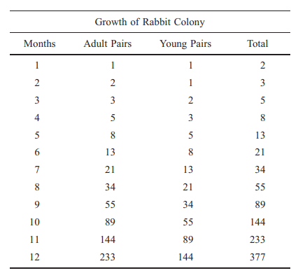

(Burton, 2009, p. 287, Chart of Rabbit Growth)

The resulting growth is called the Fibonacci sequence and is solved in terms of the Fibonacci numbers. Let $F_{n}$ denote *n*th Fibonacci number. The sequence is written as follows:

$2 = 1 + 1$ or $F_{3}=F_{1}+F_{2}$,

$3 = 1 + 2$ or $F_{4}=F_{2}+F_{3}$,

$5 = 2 + 3$ or $F_{5}=F_{3}+F_{4}$,

$8 = 3 + 5$ or $F_{6}=F_{4}+F_{5}$,

⋮ ⋮

This provides us with:

$F_{1}=F_{2}=1$, $F_{n}=F_{n-2}+F_{n-1}$, for $n ≥3$.

This sequence is one of the earliest recursive mathematical works. Burton (2011) states that Fibonacci was most likely aware of this recursive nature, but the mathematical notation did not come around until 1634. (p. 288) The most remarkable thing about the sequence is its connection to the *golden ratio* as called by the Greeks.

The golden ratio is found by:

$\frac{a}{b}=\frac{a+b}{a}=1.618…=Φ$

This ratio is found all around in nature. It is a beautiful ratio in design as it is aesthetically pleasing. This ratio has been used for centuries from Pyramids in Giza all the way to the Pepsi Logo. The connection from Fibonacci numbers to this golden ratio is observed by:

$u_{1} =\frac{1}{1}= 1$ $u_{5}=\frac{8}{5} =1.60$

$u_{2} =\frac{2}{1}= 2$ $u_{6}=\frac{13}{8}=1.625$

$u_{3} =\frac{3}{2}= 1.5$ $u_{7}=\frac{21}{13}=1.615$

$u_{4} =\frac{5}{3}= 1.66…$ $u_{8}=\frac{34}{21}=1.619$

The further we approximate the closer this ratio becomes. This connection is astonishing that it relates a simple sequence of numbers into a ratio that we can find almost everywhere in nature. Today we would calculate this with the same methods that Fibonacci used except with modern notation.

**Nemorarius**

A notable mathematician during the 13th century is named Jordanus Nemorarius. Little information is known about Jordanus but what is known is that he founded the school of mechanics. He is believed to have taught there circa 1220. His solution to the inclined plane problem solidified his fame when he published the book titled *Arithmetica.*

Jordanus gives two propositions to explore the inclined plane problem. Proposition 9 says that for a given inclined plane, the weight on the incline is the same everywhere. Following from the fact that whatever points D and E are chosen on the incline, the right triangles DFK and EGM are equal.

. 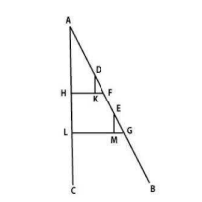

(Sophie and Egidio, 2008, p. 11, Inclined Plane)

Proposition 10 demonstrates that weights placed on slopes of the same ratios descend with the same force; they have the same positional gravity.

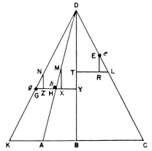

(Sophie and Egidio, 2008, p. 11, Figure for Geometric demonstration)

The geographic demonstration as written by Sophie and Egidio (2008) goes as follows:

Given the similarity of the similar triangles NGZ, DYG, DBK, we have NZ/NG = DY/DG = DB/DK.

Likewise we have MX/MH = DB/DA

We conclude by an elementary manipulation of the ratios MX/NZ = MH/NG x DK/DA.

But by construction, MH= NG; whence finally MX/NZ = DK/DA = $glh$ (p. 12)

Jordanus does not explain further as the equality of the ratios MX/NZ and DK/DA shows that movements on inclined planes can be replaced by vertical movements.

This solution is extremely important to the history of modern-day engineering mathematics. Stuff Made Here (2020) demonstrates an engineering problem that involves the inclined plane. His solution is to have the slope angle shallow enough that friction takes over and explains how this same concept is the reason why screws do not unscrew. The problem today would be solved with Newtonian physics which includes friction but still uses the property of being able to convert movements to vertical movements.

**Oresme**

During the 14th century the mathematician Nicole Oresme was born. He was born on 1323 and died on 1382. He lived a very successful life as the bursar in the University of Paris, he later became the dean of Rouen. He was appointed the financial advisor to King Charles V in 1370. Oresme’s most notable work is in infinite series. Other notable works are the first use of fractional exponents, created coordinate geometry, and opposed the stationary Earth model long before Copernicus.

Many mathematicians before the 14th century struggled due to the notation and terminology not being there. This meant that while the thoughts were there, they were unable to display it. Most would not venture past what was considered taboo, however during the Renaissance new philosophical viewpoints would permit new thoughts past taboos. Oresme ventured in this direction to tackle Infinite series.

Among the series that Oresme summed, one series is:

$\frac{1}{2}+\frac{2}{4}+\frac{3}{8}+…+\frac{n}{2n}+…=2$

Oresme provides this geometric proof.

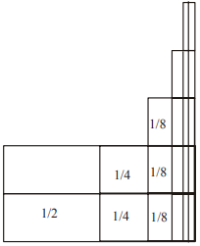

(Allen, 2003, p. 15, Geometric proof of above series)

Today we would solve these and prove with a summation and limits. Exactly like Oresme but today we have the notation to express it. These series and proofs set up very good groundwork for many future advancements, an extremely notable one is Calculus. This is because infinity was thought to not end but was unknown if it could be applied to an object. Oresme’s series and proofs allowed what was thought to be infinite and had no answer to have an answer.

**Conclusion**

In conclusion, towards the end of the Late Middle Ages we can see increasing mathematical discoveries. The High Middle Ages had the brilliant mind of Fibonacci, but the philosophical views, mathematical notation, and political situation of Europe prevented a lot of the advancement that we saw occurring towards the end of the Late Middle Ages. Oresme along with many others of that time set the groundwork for the explosion of many discoveries and mathematicians to come in the following centuries.

**References**

Fibonacci, L., & Sigler, L. E. (2003). Fibonacci’s Liber abaci : a translation into modern English of Leonardo Pisano’s Book of calculation (1st softcover printing.). Springer.

Gross, R. (n.d.). What is the golden ratio? What you need to know and how to use it. Retrieved September 14, 2020, from https://www.canva.com/learn/what-is-the-golden-ratio/

Allen, D. (2003, March 21). Medieval Mathematics. Retrieved September 16, 2020, from http://ceadserv1.nku.edu/longa//classes/mat305/resources/www.math.tamu.edu/~dallen/masters/medieval/medieval.pdf

Sophie Roux, Egidio Festa. The Enigma of the Inclined Plane from Hero to Galileo. Mechanics and Natural Philosophy before the Scientific Revolution, Kluwer Academic Publishers, pp.195-221, 2008. ffhalshs-00806464f

Stuff Made Here. (2020 June 2). I made a self correcting golf club[Video file]. https://www.youtube.com/watch?v=o5Cv9fvajrc

Lundin, E., &amp; R, B. (2019, June 28). The 5 Major Causes Of The Dark Ages. Retrieved September 18, 2020, from https://historythings.com/5-things-that-actually-caused-the-dark-ages/

Snell, M. (n.d.). Defining the Middle Ages. Retrieved September 18, 2020, from https://www.thoughtco.com/defining-the-middle-ages-part-6-1788883

Babb, J. (2001, August 1). Mathematical Concepts and Proofs from Nicole Oresme: Using the History of Calculus to Teach Mathematics. Retrieved September 17, 2020, from http://winnspace.uwinnipeg.ca/bitstream/handle/10680/1319/REVISED%20SCED901%20Oresme%20Paper.pdf;jsessionid=74573A37E0EB085C4EFC447DCF71F011?sequence=1